SPRING NEWSLETTER



Dear Lochbroom & Ullapool Church of Scotland Family,

Soon we will celebrate Easter, the new dawn and the amazing work of salvation. God’s plan for us was fulfilled in Jesus' resurrection … It is a season of joy! This year we raise our “Alleluias” and proclaim “Christ is risen, He is risen indeed! We celebrate the stone rolled away, but with war raging in the Middle East and fears of WW3 looming. We celebrate the empty tomb this year with worry and realistic fears about economic difficulties, inflation, rising fuel costs and food insecurity. We celebrate Jesus risen with a deepening understanding of the mental health crisis which has been born out of pandemic-induced loneliness, depression, anxiety and recent deaths in this village. This Easter, we come to the tomb, and although we are shown the joy and light of the new dawn, perhaps we are world-weary, numb, bewildered, sad and tired. That’s okay.

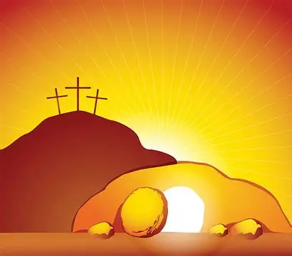
When Peter sees the empty tomb, he runs away. When “the beloved disciple” sees it, he believes without comprehension. When Mary sees it, she weeps and waits for more in the holy darkness. But all of them, without exception, experience Easter. The resurrection meets them where they are, no matter how they feel, no matter what is happening around them. We come to the empty tomb, to the new dawn, as ourselves, no matter who we are or how we feel. The empty tomb does not ask us to shed everything that weighs on our hearts ahead of time.

The empty tomb comes to us as the risen Jesus comes to us. The risen Jesus barges into our lives and calls us by name in love. He says: ‘I know you, I know who you are and everything you have been through, and all I have done – that has been for you and I will always walk with you’. No matter your experiences of the last week, month, year, or decade, our risen God walks with us in all we experience and everywhere we go. That is the power this day. Jesus bursts from the tomb filled with light and life, breaks forth into our broken and sometimes painful world redeeming it by his love, his faith and his salvation. New life comes; it cannot be stopped. It meets us where we are and does not expect us to immediately be filled with joy. But when it comes, it brings to us the knowledge that every change, every sorrow, every hope, and everything we experience is held in the arms of the risen Christ. Like those who were first to visit the empty tomb, we might be filled with bewilderment, stumble and feel like we cannot get back up. We might want to run, or we might just feel sad. But like the Christ of the empty tomb, we will also rise. This is the promise of resurrection; this is the Joy of Easter.

Christ is with us. He is risen, He is risen indeed, Hallelujah!

A very Happy Easter to you and yours,

Rev. Heidi

What’s Coming up in the church


Saturday, March 21st - Curry Night at the Church - Several Curries to try. Come in and dine or carry out. A donation of £7.50 is suggested. 5:30 – 8.00pm



Saturday, March 28th - Fairtrade Big Brew. A lovely variety of Home baking and refreshments. Come along to support the work of Fairtrade. 2.00 – 4.00pm

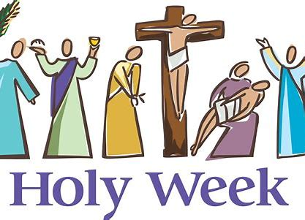

Sunday, March 29th -Palm Sunday- We begin Holy week with a celebratory Sunday. We will wave our Palms and prepare for the King of Kings.

Maundy Thursday, April 2nd 7.00pm – A Tenebrae Service- a simple service of readings, music and candlelight. Communion will be offered after the service if you wish to stay on.

Good Friday- April 3rd 12.00 - 3.00pm. A time for quiet reflection in the church, with refreshments served. Rev. Heidi will offer a brief reflection every ½ hour. The Passion movie will be playing from 12 noon. Come to watch it all or just dip in and see some short clips.

Holy Saturday, April 4th 12.00 - 4.00pm. Easter Fun at Am Pollan Park. The Ullapool Easter Bunny will be doing the rounds handing out eggs and then some Egg rolling, hunting, painting, throwing, pie chucking, face painting and an egg for solving an Easter Quiz!

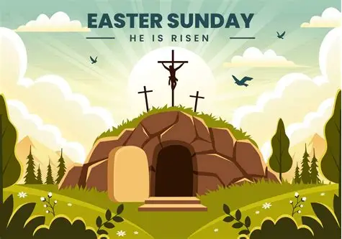
Easter Sunday, April 5th

Praise on the Pier- 9.00am – a traditional Easter service led by local clergy. This year including a brief children’s address.

Celebration service -11.00am followed by Communion - a family friendly service including the wonderful story of Easter, Easter magic, The Hallelujah Chorus (an attempt at it!) an Egg hunt with a twist and decorating our floral cross together.

We would sure love to have a full church on Easter Day…

We would love to see you!

